Our client Scott Gordon has a website www.familylawadvocate.com that we want some updates to. Please provide a quote.

- As they have on the site http://www.merelfamilylaw.com/ he would like a “Maintenance Calculator” similar to what they have here http://www.merelfamilylaw.com/illinois-maintenance-calculator/

You will find on that site they have a tab (see below)
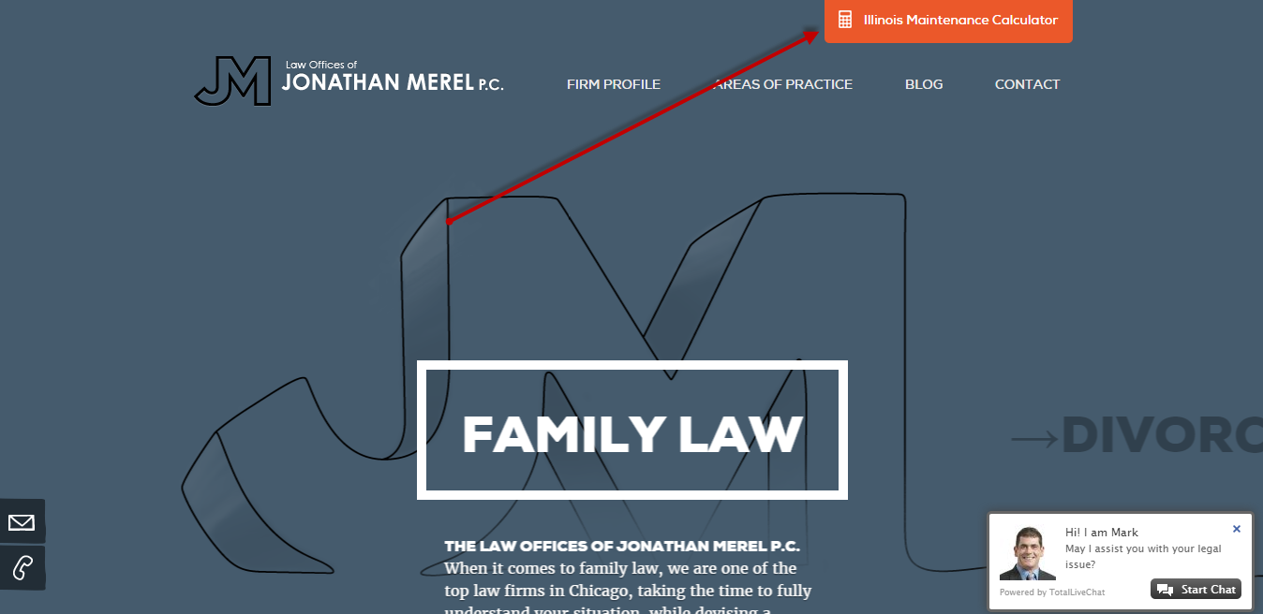
I need the same functionality as http://www.merelfamilylaw.com/illinois-maintenance-calculator/ I think the best place to add this would be under “Resource & Information” . Change that to “Resources & Information” still have that link to http://www.familylawadvocate.com/resources/ but have a drop down “Illinois Maintenance Calendar” that links to www.familylawadvocate.com/illinois-maintenance-calculator/ with the functionality of http://www.merelfamilylaw.com/illinois-maintenance-calculator/

- We need to create a new page to the website which will also be a drop down under “Resources & Information” but this page will be titled “Latest IL Family Law Case News” and the URL should be http://www.familylawadvocate.com/latest-illinois-family-law-case-news
So now, under “Resources & Information” there should be two drop downs
Latest IL Family Law Case News http://www.familylawadvocate.com/latest-illinois-family-law-case-news
Illinois Maintenance Calendarwww.familylawadvocate.com/illinois-maintenance-calculator/

*This new page http://www.familylawadvocate.com/latest-illinois-family-law-case-news should have the same look and feel as the “Testimonials” page http://www.familylawadvocate.com/testimonials/

*the content for this page is at the end of this word document

- IF possible, he would like to set up a scrolling box with a blurb and a “Read More” option as we have on the home page for “Client Testimonials” where the below red arrow is. IF you look at where the below box is on the left, if we can add “Family Law News” with the same scrolling that would be great. If not, no big deal please let me know.

----
Content for http://www.familylawadvocate.com/latest-illinois-family-law-case-news

Latest IL Family Law Case News
Attorney M. Scott Gordon comments on the latest Divorce and Family Law cases in Chicago and Illinois, as well as current developments of interest. If you have questions regarding Divorce or Family Law in Chicago contact the M. Scott Gordon & Associates today.
February 4, 2016
How much "weight" must a Judge give to the opinion of a child and the allocation of parenting time? In a recent case (In re Marriage of Adamson), a Judgment of dissolution was entered 6 years ago granting the parties joint custody and setting forth an agreed parenting schedule. When the children were 13 and 8, the mother filed a Petition to modify the father's parenting time. The trial Court concluded that changing the schedule was not in the children's best interest, even though older child stated a preference for more time with his mother. The mother filed an appeal, but the appellate court upheld the trial court's decision. Why? The Court of Appeals stated that while a mature child's preference as to custody should be given considerable weight when based on sound reasoning, a court is not precluded from finding that child's preference is not in child's best interest. Here, the trial court felt the child's description of preference described mere normal teenage/parent behavior and misunderstandings.

February 2, 2016
Effective January 1, the only method (or basis) for divorce in Illinois is "no fault". Previously, while you could file a no fault divorce action, you also had the option of filing a divorce based upon fault. That has now been abolished. How does this effect you? Not very much. Under the previous statute with fault, a Court still had no authority to award you more property based upon fault. However, the change will hopefully allow couples and the Judge to focus on issues the Court can address, namely, the children, finances, support and property division.

February 1, 2016
In a Child Custody dispute, the Court may appoint an expert to give an opinion as to which parent is more suitable to be named the custodian. What if a parent disagrees with that opinion after the divorce / custody case is completed? Does the aggrieved parent have a right to sue the expert for malpractice? In a new case before the Illinois Court of Appeals (Heisterkamp v. Pacheco), a Plaintiff filed such a lawsuit against a clinical psychologist who was the court-appointed expert in the Plaintiff's divorce proceeding. In that case, the expert diagnosed the Plaintiff with "obsessive-compulsive personality" and he ultimately lost custody. In the lawsuit, he alleged the diagnosis deviated from the proper standard of care. The Appeals Court here ruled that the expert acted at the direction of the court in dissolution proceedings and is entitled to absolute immunity regardless of whether direction given was proper under the Illinois divorce statute.

January 29, 2016
A new case issued by the Illinois Court of Appeals gives guidance to Judges once they make a finding that abuse has occurred. In the case of Sanchez v. Torres, the Court heard an appeal from a petitioner who had sought a 2 year "plenary" order of protection. After the evidentiary hearing, the trial court found abuse. The appeals court held that a court may not decide instead to then issue a civil restraining order because that type of order does not have the same effect or rights as an Order of Protection. The Illinois Domestic Violence Act mandates the issuance of an order of protection once a victim makes a showing of abuse.

